1. NOTE:
   1. \* means exactly one word match.
      1. example:
         1. \*.image would match to the following
            1. Jatin.image
            2. xyz.image
         2. \*.image will not match to the following
            1. image
            2. image.hello
   2. # means zero or more word matching.
      1. example:
         1. #.image will match to the following
            1. image
            2. Jatin.image
            3. Jatin.bansal.image
         2. #.image.# will match the following
            1. image
            2. hello.what.image
            3. hello.what.image.dfhdfd.here
            4. image. hello.what
2. 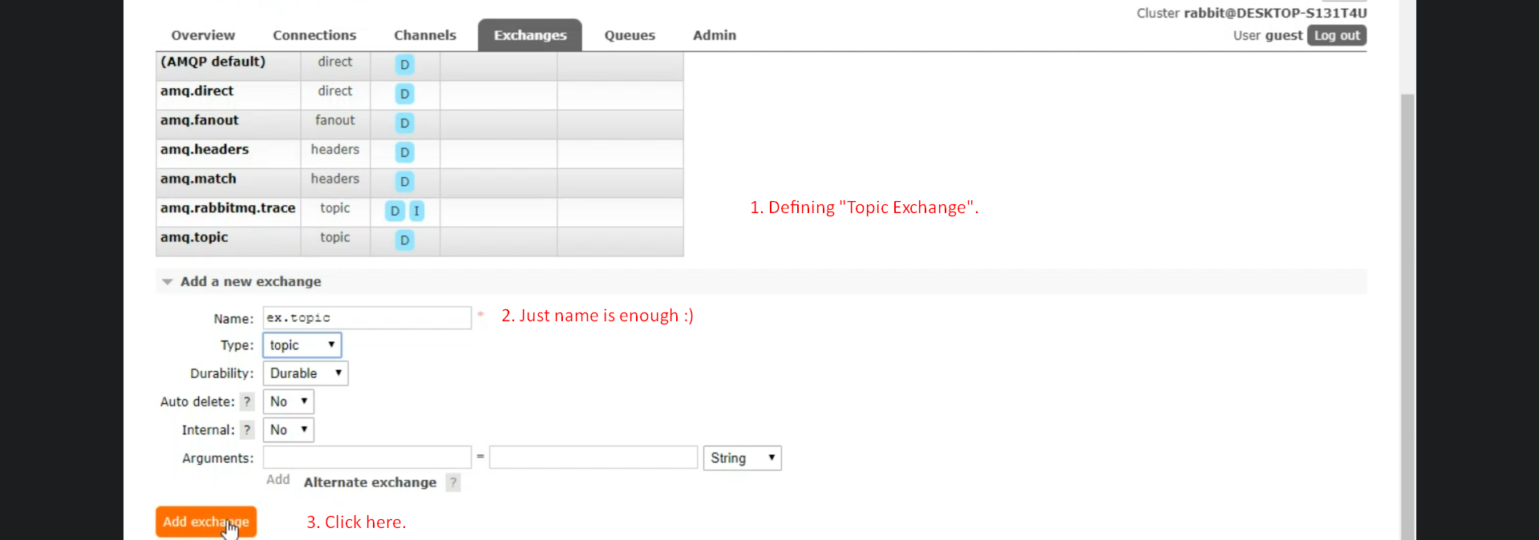
3. Creating Queue:  
   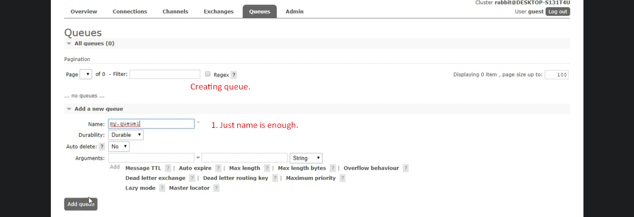
4. 
5. 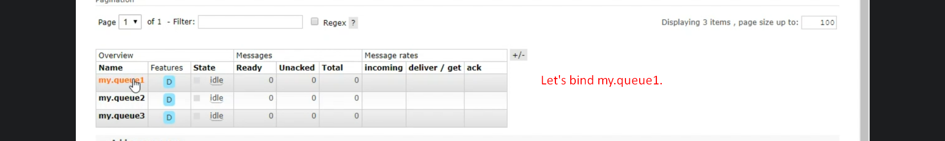
6. 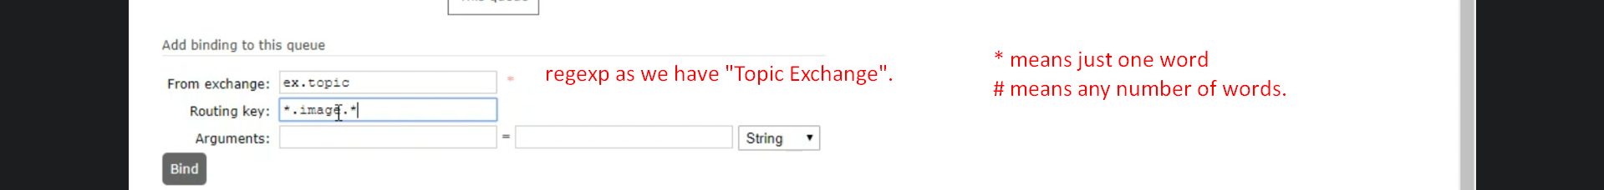
7. 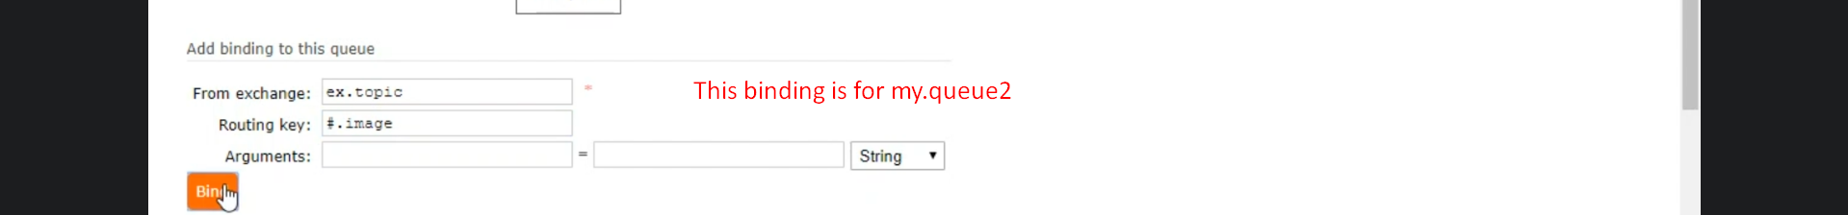
8. 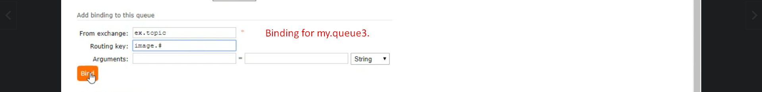
9. 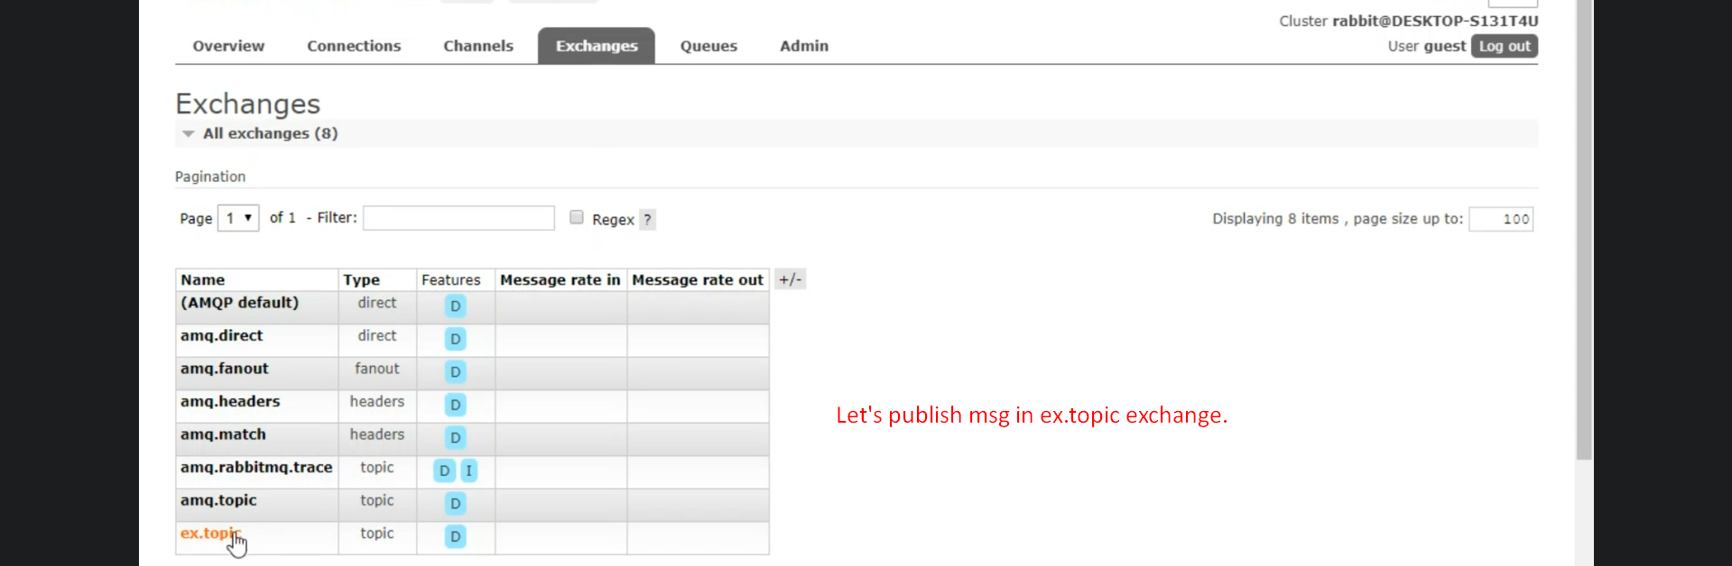
10. 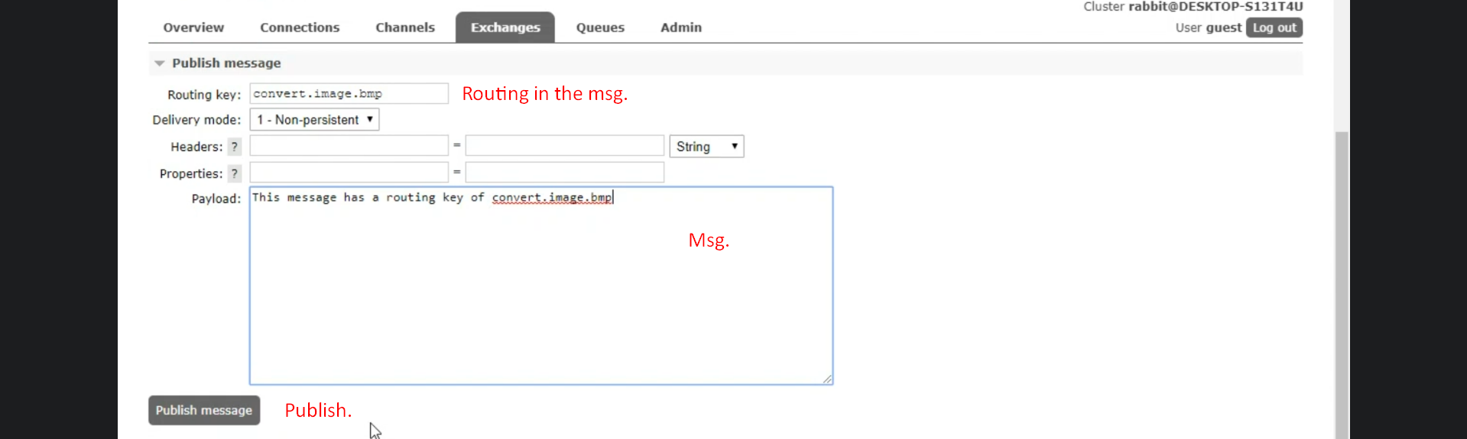
11. 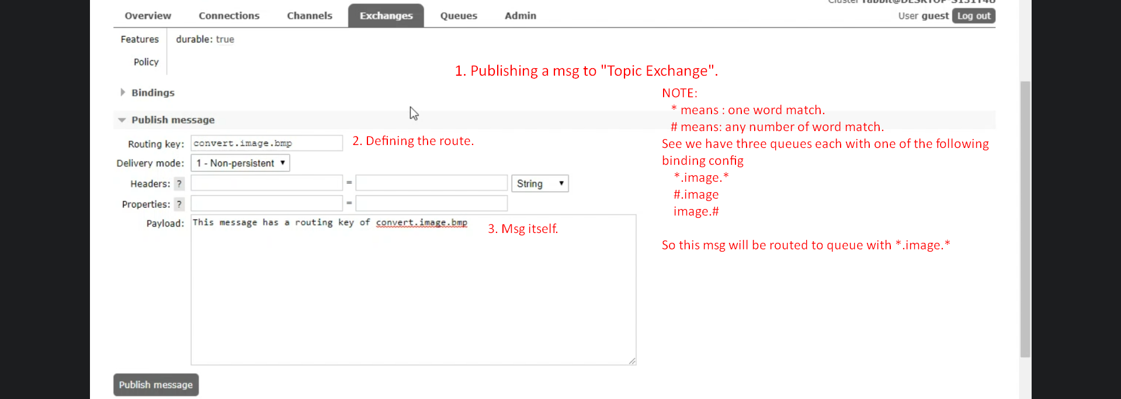
12. 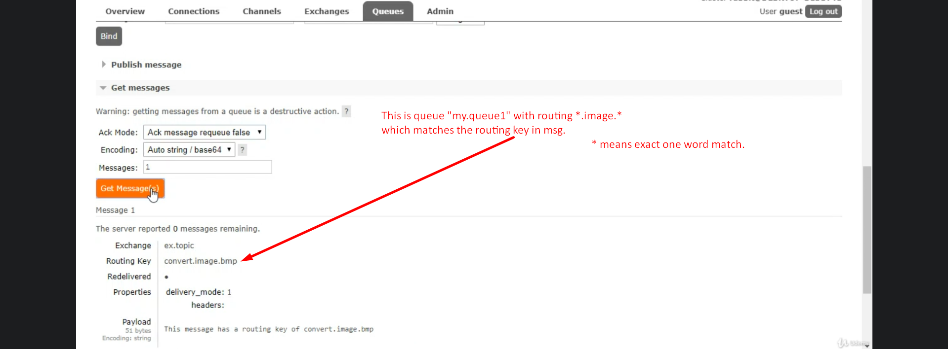
13. 